* CREATE DATABASE school_db.
* CREATE TABLE students(studentId int PRIMARY KEY AUTO_INCREMENT,student_Name varchar(20),age int ,class varchar(20) , address varchar(50));
* INSERT into students(student_Name,age,class,address)values("Vatsal","21","Python","Surat");

INSERT into students(student_Name,age,class,address)values("Harsh","21","Java","Surat");

INSERT into students(student_Name,age,class,address)values("Sahrukh","21","Java","Daman");

INSERT into students(student_Name,age,class,address)values("Ronak","22","PHP","Ahmedabad");

INSERT into students(student_Name,age,class,address)values("Vishal","21","Python","Surat");

INSERT into students(student_Name,age,class,address)values("Salman","23","Testing","Navsari");

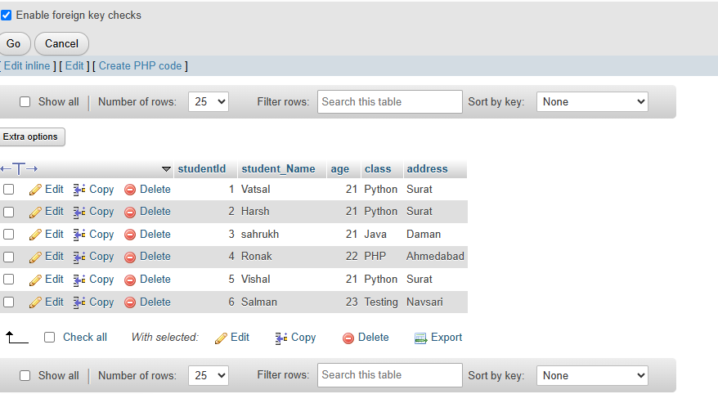

* SELECT student_Name,age FROM students

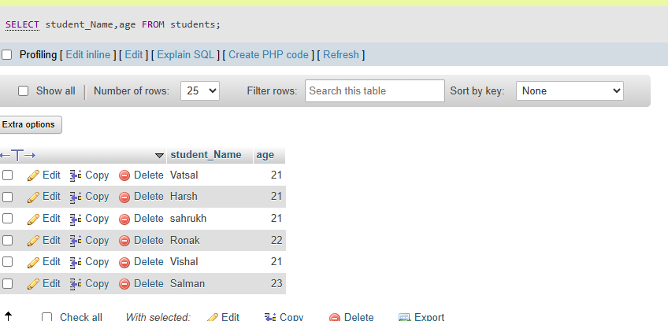

* SELECT * FROM students WHERE age>10

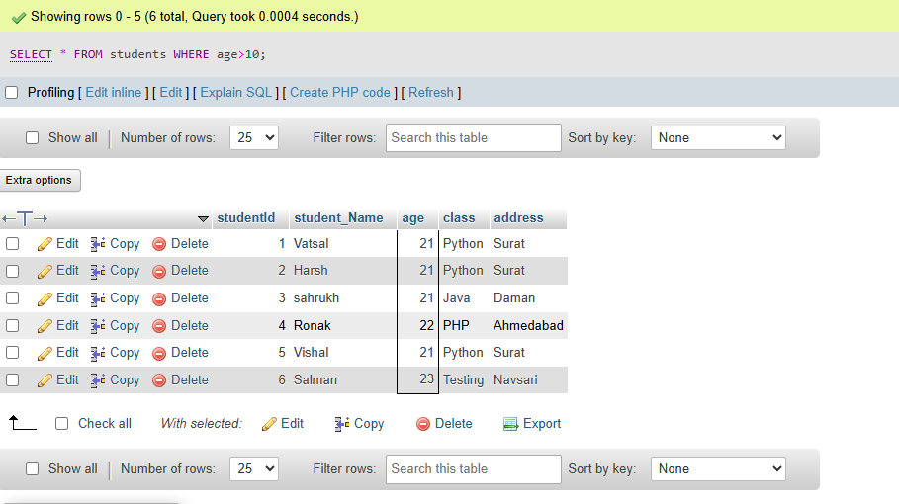

* CREATE TABLE teacher(teacher_id int PRIMARY key AUTO_INCREMENT,teacherName varchar(40)not null,subject varchar(40)not null , email varchar(20) UNIQUE);

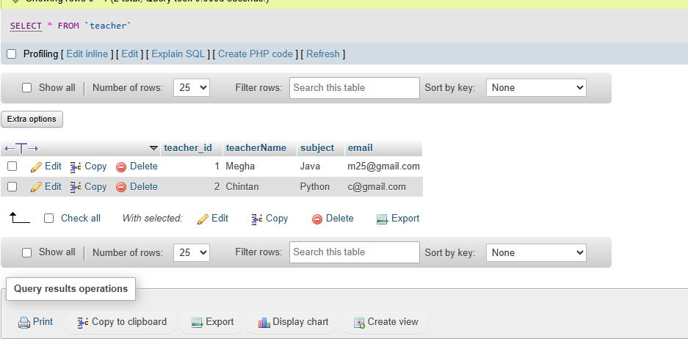

* alter table students add CONSTRAINT FOREIGN KEY (teacherId) REFERENCES teacher(teacher_id);
* CREATE TABLE courses(course_id int PRIMARY key,course_name varchar(20),course_credit int );
* alter table courses add COLUMN course_duration;
* ALTER TABLE courses DROP COLUMN course_credit
* drop table students
* drop table teacher
* INSERT INTO `courses`(`course_id`, `course_name`, `course_duration`) VALUES (101,"Python", "4 month");

INSERT INTO `courses`(`course_id`, `course_name`, `course_duration`) VALUES (102,"Java", "3 month");

INSERT INTO `courses`(`course_id`, `course_name`, `course_duration`) VALUES (103,"PHP", "2 month");

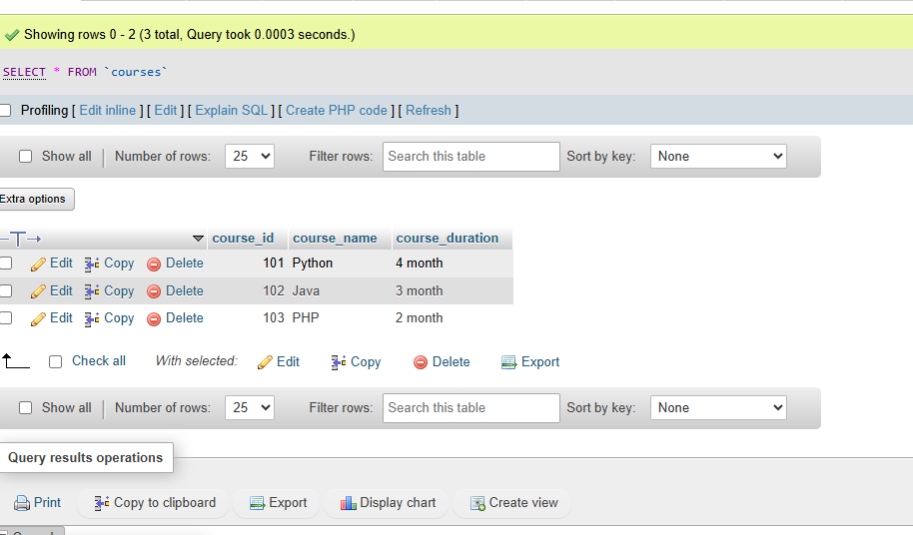

* UPDATE courses set `course_duration`="4 month" where `course_id`=102

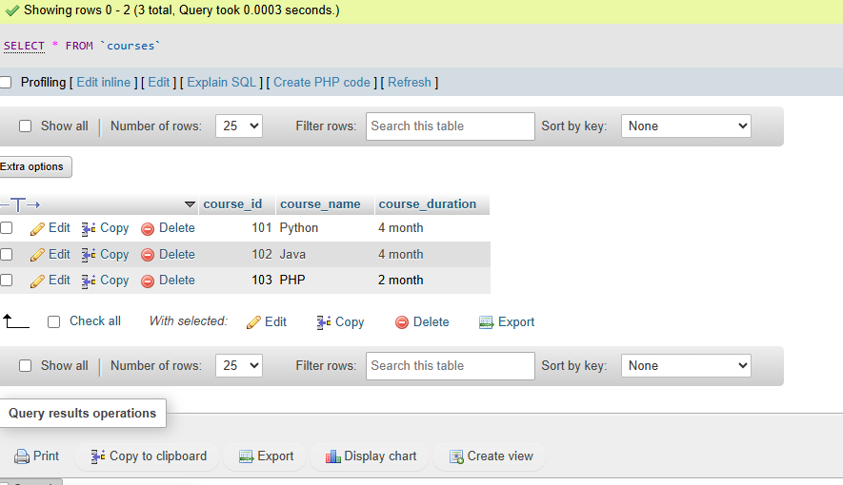

* DELETE FROM `courses` WHERE `course_id`=103

